الجمهورية اللبنانية
الاسم والشهرة:--------------------
رقم المرشح :----------------------

رقم المرشح :----------------------
وزارة التربية والتعليم العالي الإمتحانات الرسمية لشهادة الإمتياز الفني
المديرية العامة للتعليم المهني والتقني لدورة عام 2021 الأولى
=============
الإختصاص والرمز : المعلوماتية الإدارية (23106)
المادة : البحث العملاني المعدل : (8)
المستندات المسموح بها : لا شيء المدة : ساعة ونصف
الإجابات على "كراس الإجابة"

- Choose the correct answer: (1pt/ correct answer)

- In an orthogonal plane, to solve a linear program, the number of variable is:  - 2  - 3  - 4  - None of the above | - Identify the type of the feasible region given by the set of inequalities:  x - y <= 1  x - y >= 2  where both x and y are positive.  - A triangle  - A rectangle  - An unbounded region  - An empty region
- Assuming the objective is : MAX Z=2x+3y  With the following constraints:  3x + y ≤ 5  2x + 3y ≤ 8  x + 2y ≤ 5  x;y≥0  What is the used method to find Z?  - The simplex method  - Vogel's approximation method  - North corner method  - None of the above | - Assuming the objective is:  MAX Z=2X1+3X2-4X3  With the following constraints:  2X1 + 3X2+4X3+2X4 ≤ 50  3X1 + 2X2+X3+2X4 ≤ 38  X1, X2+X3+X4≥0  What is the used method to find Z?  - The graphical method  - The simplex method  - The transportation method  - None of the above
- Given the following linear program:  X₁ + X₂ ≤ 4  X₁ ≥ 6  X₁ ≥ 0;X₂ ≥ 0  Then the problem admits  - A unique solution.  - No solution.  - Infinity of solutions. | - The solution to a transportation problem with m-rows and n-columns is feasible if the number of positive allocations (basic variables) is:  - m + n  - m *n  - m+n-l  - m+n+l
- The north west corner method requires filling the quantity table starting by the:  - Lower right corner of the table.  - Upper right corner of the table.  - Highest costly cell of the table.  - Upper left-hand corner of the table. | - The total margin of critical tasks in a PERT diagram is:  - Positive  - Null(Zero)  - negative  - Strictly greater than its free margin
- What enables us to determine the earliest and latest times for each of the events and activities and thereby helps in the identification of the critical path?  - Linear programming  - Review Technique (PERT)  - Queuing theory  - Deployment of resources | - In transportation problem, the method used to fixe a starting solution by calculating the difference between the two lowest in a row and in a column is:  - North corner method  - Vogel's approximation method  - Least cost minimal  - Simplex method

- Open questions: (1pt/ correct answer)

- Formulate the problem’s constraints according to the following table that represents the daily required materials M1, M2 with their availabilities to produce the products P1, P2:

 | M1 | M2
P1 | 2 | 3
P2 | 4 | 1
Available quantities | 100 | 120

- Assuming that the daily profit of P1, P2 is approximately 50$ and 80$. Formulate the objective Z of the problem?
الإختصاص والرمز : المعلوماتية الإدارية (23106)
المادة : البحث العملاني

- Find a basic solution (Only a basic solution) using the North west Corner method for the following transportation table:
 | D1 | D2 | D3 | Supply
S1 | 5 | 1 | 7 | 10
S2 | 6 | 4 | 6 | 80
S3 | 3 | 2 | 5 | 15
Demand | 35 | 20 | 50

- Find a basic solution (Only a basic solution) using Least Cost method for the following transportation table:
 | D1 | D2 | D3 | Supply
S1 | 5 | 1 | 7 | 10
S2 | 6 | 4 | 6 | 80
S3 | 3 | 2 | 5 | 15
Demand | 35 | 20 | 50

- Find a basic solution (Only a basic solution) using Vogel’s approximation method for the following transportation table:
 | D1 | D2 | D3 | Supply
S1 | 5 | 1 | 7 | 10
S2 | 6 | 4 | 6 | 80
S3 | 3 | 2 | 5 | 15
Demand | 35 | 20 | 50
- Check the following transportation problem solution if it is optimal or no? and find its cost?
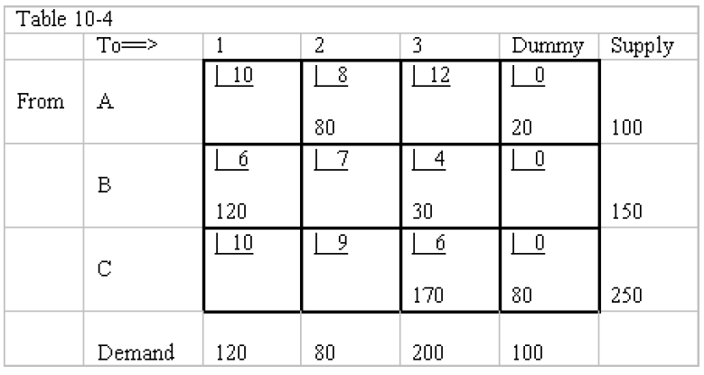
- Determine the level of the tasks for the following project activities:
Activity | Predecessor | Duration (Days)
A | - | 4
B | A | 58
C | B | 2
D | B | 2
E | C | 1
F | D | 1

- Construct the PERT network for the following project activities:
Activity | Predecessor | Duration (Days)
A | - | 4
B | A | 58
C | B | 2
D | B | 2
E | C | 1
F | D | 1
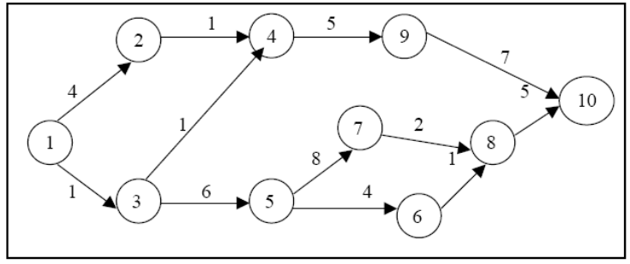
- Find the critical path of the following PERT network (Fig 1)?

- Find the minimal duration of the following PERT network (Fig 1)?
Fig 1

